|  |
| --- |
| Evan McConnell 20080222 |
| Game Design Document |
| Game Design Practicum |

Table of Contents

Requirements 3

Player-Based Mechanics 3

• Navigation – 3

• Using weapons or other objects – 3

• Interacting with objects – 3

• Object inventory – 3

• Interacting with other characters – 3

• Attributes – 3

• Line of sight – 3

• Proximity-Based Hearing – 4

• Attack- 4

NPCs 4

• Navigation – 4

• Artificial Intelligence – 4

• Interacting with Other Characters – 4

Objects 4

• Key – 4

Game AI 5

• Spawn Objects – 5

• Difficulty – 5

Static Visuals 5

• 3D Characters – 5

• 2D Textures – 5

• Image for Splash Screen – 5

• Sprites for Buttons – 5

Dynamic Visuals 6

• Animations for characters- 6

• Enemy Sight- 6

Audio 6

• Background Audio – 6

• Sound Effects for in-Game Events – 6

• Character Audio- 6

In-Game User Interface 7

• Minimap- 7

• Information- 7

• Pause Menu- 7

Out of Game User Interface 8

• Splash Screen- 8

• Main Menu- 8

• Options Menu- 8

Levels 9

• Level Generation- 9

• Level Transition- 9

Requirement Table 10

Development Phases 11

Phase 1 11

Phase 2 12

Phase 3 13

Phase 4 14

# Requirements

## Player-Based Mechanics

### Navigation –

* + The player should be able to move around using WASD. Using a top-down facing camera with no rotation, the A and D buttons should move the player left and right respectively, while W and S should move them up and down. (RQ_PBM_1)

### Using weapons or other objects –

* + There should be items to be used in the game, such as keys to be collected and possible power-up items to be decided upon at a later point. (RQ_PBM_2)

### Interacting with objects –

* + There should be doors at the end of each level, which can only be opened with the press of a button once a key is obtained from within the level. (RQ_PBM_3)

### Object inventory –

* + The player should be able to store a key or item once they pick it up and this should be visible on the player’s HUD. (RQ_PBM_4)

### Interacting with other characters –

* + In between levels, there should be a small room the player must pass through which contains a single NPC that should talk to the player and supply the player with new abilities and items, should they be available. (RQ_PBM_5)

### Attributes –

* + There should be a lives system. (RQ_PBM_6)
    - The player should have a limited number of lives with which to complete each level.
    - Upon running out of lives, the game ends.
    - The player can replenish lives between levels.

### Line of sight –

* + The player should always be looking in the direction of the cursor, which should be visible on the screen. (RQ_PBM_7)
  + Only objects in the player’s line of sight should be visible. (RQ_PBM_8)

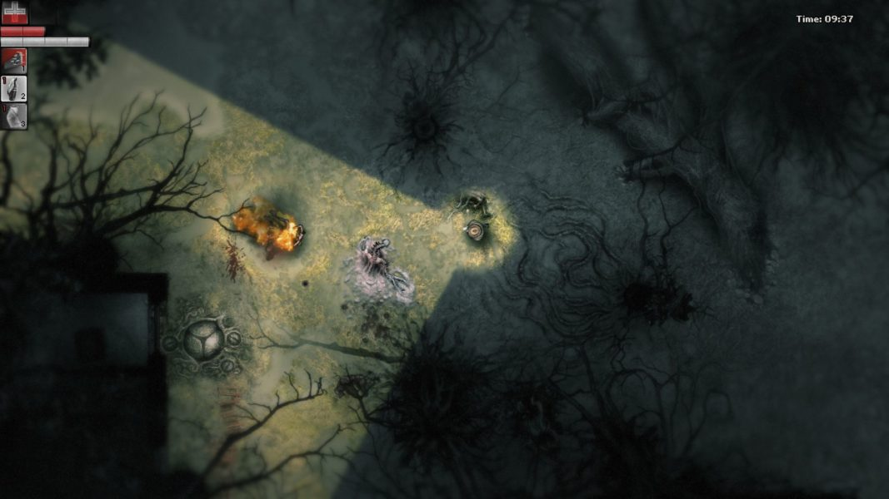

### Proximity-Based Hearing –

* + If an enemy is nearby and outside of the player’s field of view, the player should be able to hear the enemy. The player should not be able to tell the enemies exact location through this, but the enemy’s presence should be made known. (RQ_PBM_9)

### Attack-

* + If the player gets close enough behind an enemy an on-screen prompt should appear for the player to press a button to eliminate the enemy. At which point the enemy should disappear after a brief animation. (RQ_PBM_10)

## NPCs

### Navigation –

* + Certain NPCs should be able to navigate the levels. They should follow strict pre-set patrol routes using NavMeshs. (RQ_NPC_1)

### Artificial Intelligence –

* + The enemy NPCs should be able to detect the player when they enter the enemy’s line of sight, possibly through triggers, or if they hear the player moving too close to them. Once they have detected the player they should switch from a patrolling state to a state of pursuit.
    - When in this state of pursuit, the enemies should chase after the player.
      * If an enemy comes into contact with the player, a life should be deducted from the player and they are sent back to the last checkpoint. If the player has no more lives, the game ends and they are presented with a ‘Game Over’ screen. (RQ_NPC_2)
      * While being pursued, a countdown timer should be displayed to the player. Once this reaches zero, all enemies should return to their original patrols. Entering an enemy’s line of sight while being pursued should reset the timer. (RQ_NPC_3)

### Interacting with Other Characters –

* + There should be a pop-up dialogue system which the NPC can use to converse with the player.
    - The player should not be able to respond to what the NPC says, they should simply be locked out of movement and their field of view should also be locked while in dialogue. (RQ_NPC_4)
    - The dialogue text should appear on screen in a text box. It should scroll on to screen a paragraph at a time, with the player being prompted to press a key before the next paragraph begins. (RQ_NPC_5)

## **Objects**

### Key –

* + In each level, there should be keys to be collected by the player before they can proceed on. (RQ_OBJ_1)

## Game AI

### Spawn Objects –

* + The layout of each level should be procedurally generated, consisting of a 3x3 grid of rooms.
    - Each room should contain guards and possibly 1 key. (RQ_AI_1)
    - There should be an exit door in a room other than the one the player enters from. (RQ_AI_2)

### Difficulty –

* + The difficulty level should be changeable from the Main Menu before the game starts. (RQ_AI_3)
  + There should be two levels of difficulty, easy and hard.
    - Increasing the difficulty should result in more keys needed before progressing and possibly more enemies spawning. (RQ_AI_4)

## Static Visuals

### 3D Characters –

* + The game should have characters consisting of 3D models. These models will either be created by me or sourced elsewhere. (RQ_SV_1)

### 2D Textures –

* + Both the environment and characters should have 2D texture maps applied to them. These will be created by myself, if the model was, or most likely packaged with the model if I did not create it. (RQ_SV_2)

### Image for Splash Screen –

* + There should be an image on the splash screen and Main Menu. This will either be a screenshot from the game or a separate image designed by me. (RQ_SV_3)

### Sprites for Buttons –

* + Buttons will be used in the Main Menu and the pause menu. These will all be designed by me. (RQ_SV_4)

## Dynamic Visuals

### Animations for characters-

* + The main character will have keyframed animations, designed by me. These should include: (RQ_DV_1)
    - Walking animation.
    - Running animation.
    - Death animation.
  + The NPCs should also have keyframed animations designed by me. These should include: (RQ_DV_2)
    - Walking animation. (enemy)
    - Running animation. (enemy)
    - Player spotted animation. (enemy)
    - Player caught animation. (enemy)
    - Talking animation. (friendly)

### Enemy Sight-

* + The enemy’s line of sight should be visible as torchlights on the environment. (RQ_DV_3)

## Audio

### Background Audio –

* + There should be at least 2 audio tracks in the game, one for each corresponding AI state.
    - When the enemy guards are patrolling there should be a calm music track playing. (RQ_A_1)
    - When the guards switch to pursuing the player, a second audio track should replace the calm one. If the guards return to their default state, so should the audio track. (RQ_A_2)

### Sound Effects for in-Game Events –

* + When the player is caught by an enemy.
  + When an enemy spots the player.
  + When initiating dialogue with the friendly NPC.
  + When the player interacts with a button in a menu.
  + (RQ_A_3)

### Character Audio-

* + The player should have a walking sound effect.
  + The enemies should have a distinct walking sound.
  + The friendly NPC should have audio effect playing to indicate they are speaking.
  + (RQ_A_4)

## In-Game User Interface

### Minimap-

* + Should start blank and be revealed as the player explores the level. (RQ-IGUI_1)
  + Should be in the corner of the screen. (RQ- IGUI_2)
  + Player line of sight and arrow or cone of vision shown to indicate the direction they are facing. (RQ- IGUI_3)
  + If an enemy’s cone of vision is visible to the player, their location should be visible on the map. (RQ- IGUI_4)
  + As the player sees items, they should be shown on the map and should stay on the map until they are collected. (RQ- IGUI_5)

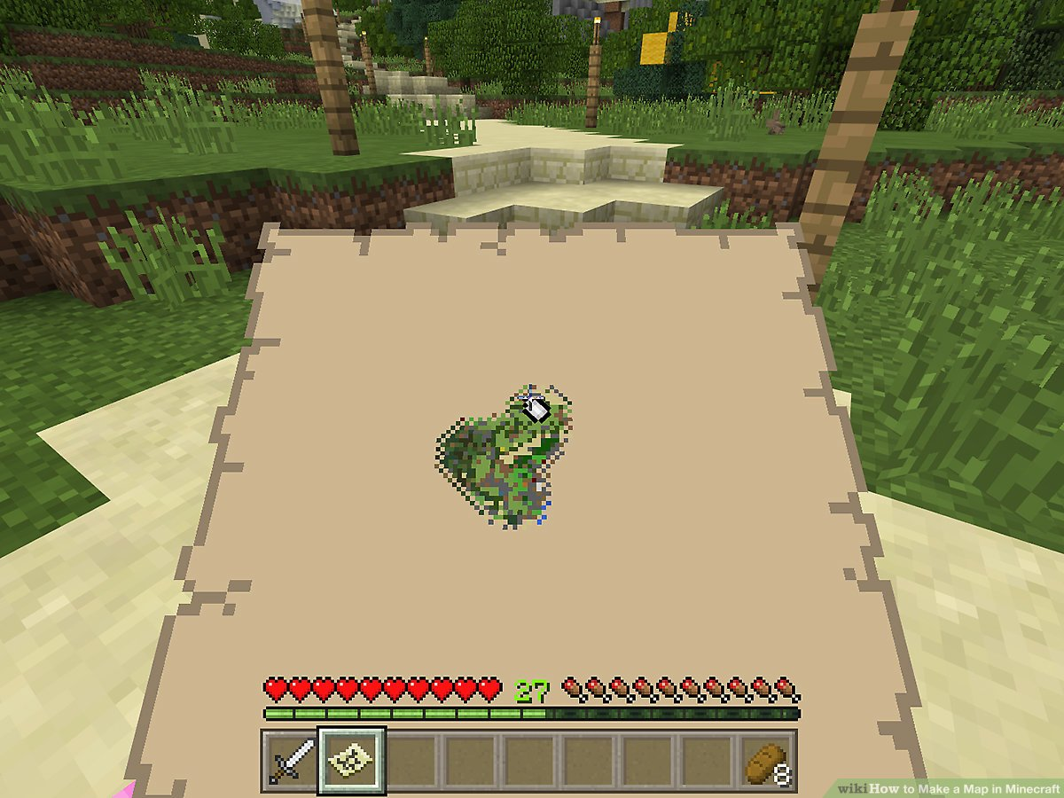

### Information-

* + Keys-
    - A line of keys should be visible at the edge of the screen. One for each key the player needs to collect. (RQ- IGUI_6)
    - They should start greyed out, but as the player collects them, they should be crossed off to give the player feedback on their progression. (RQ_IGUI_7)
  + Loading-
    - When the player is in between levels a pulsing line of text should appear at the bottom of the screen to alert the player. (RQ_ IGUI_8)

### Pause Menu-

* + There should be 3 options: (RQ_ IGUI_9)
    - Resume Game (exits the pause menu).
    - Options (opens the options menu). From here you should be able to do adjust the game’s volume or mute sounds altogether.
    - Quit Game (returns to the main menu).

## Out of Game User Interface

### Splash Screen-

* + Simple text that prompts the player to press the enter key.
  + This should transition them to the main menu.
  + (RQ_ OoG_1)

### Main Menu-

* + Three Buttons:
    - ‘Start Game’ launches the game.
    - ‘Options’ leads to the Options Menu.
    - ‘Exit Game’ quits the game and returns to the Desktop.
  + (RQ_ OoG_2)

### Options Menu-

* + A slider to control the volume of the game.
  + A switch to mute/unmute the games audio.
  + (RQ_ OoG_3)

## Levels

### Level Generation-

* + Each level will be procedurally generated using a custom system. (RQ_L_1)
  + Each level will consist of a 3x3 grid of 9 rooms chosen at random from a pre-set array of room prefabs. (RQ_L_2)
  + In each room, there will be a location for a key to spawn and multiple locations for guards to spawn. Depending on the difficulty and current progress through the game, more or less of these will be spawned. (RQ_L_3)
  + In each room, there will be a possible location for an exit, though only one will ever spawn in a level. This will open only when the player has collected all the keys in the level. (RQ_L_4)

### Level Transition-

* + Upon starting the game, the player will spawn in a small room, containing a friendly NPC the player can talk to, and a door. (RQ_L_5)
  + The main level will still be loading at this point as shown by a UI element. Once the level has loaded the text will disappear and the door will open. (RQ_L_6)
  + After exiting each level, the player will enter an identical room to this one, the previous level will unload, and this room will act as a waiting room as the next level loads in. There will be no loading screens. (RQ_L_7)

# Requirement Table

|  |  |
| --- | --- |
| Requirement | Priority Level |
| (RQ_PBM_1) | 1 |
| (RQ_PBM_2) | 1 |
| (RQ_PBM_3) | 2 |
| (RQ_PBM_4) | 1 |
| (RQ_PBM_5) | 3 |
| (RQ_PBM_6) | 2 |
| (RQ_PBM_7) | 1 |
| (RQ_PBM_8) | 3 |
| (RQ_PBM_9) | 3 |
| (RQ_PBM_10) | 2 |
|  |  |
| (RQ_NPC_1) | 1 |
| (RQ_NPC_2) | 2 |
| (RQ_NPC_3) | 2 |
| (RQ_NPC_4) | 3 |
| (RQ_NPC_5) | 3 |
|  |  |
| (RQ_OBJ_1) | 1 |
|  |  |
| (RQ_AI_1) | 1 |
| (RQ_AI_2) | 1 |
| (RQ_AI_3) | 3 |
| (RQ_AI_4) | 3 |
|  |  |
| (RQ_SV_1) | 4 |
| (RQ_SV_2) | 4 |
| (RQ_SV_3) | 4 |
| (RQ_SV_4) | 2 |

|  |  |
| --- | --- |
| Requirement | Priority Level |
| (RQ_DV_1) | 4 |
| (RQ_DV_2) | 4 |
| (RQ_DV_3) | 2 |
|  |  |
| (RQ_A_1) | 4 |
| (RQ_A_2) | 4 |
| (RQ_A_3) | 3 |
| (RQ_A_4) | 3 |
|  |  |
| (RQ_IGUI_1) | 2 |
| (RQ_IGUI_2) | 1 |
| (RQ_IGUI_3) | 1 |
| (RQ_IGUI_4) | 2 |
| (RQ_IGUI_5) | 2 |
| (RQ_IGUI_6) | 1 |
| (RQ_IGUI_7) | 2 |
| (RQ_IGUI_8) | 2 |
| (RQ_IGUI_9) | 2 |
|  |  |
| (RQ_OoGUI_1) | 2 |
| (RQ_OoGUI_2) | 2 |
| (RQ_OoGUI_3) | 3 |
|  |  |
| (RQ_L_1) | 1 |
| (RQ_L_2) | 1 |
| (RQ_L_3) | 1 |
| (RQ_L_4) | 1 |
| (RQ_L_5) | 2 |
| (RQ_L_6) | 2 |
| (RQ_L_7) | 2 |

# Development Phases

## Phase 1

Goals: This phase will be all about getting the level generation and character movement working, as well as laying the foundation for the in-game user interface.

Requirements to be featured: (RQ_PBM_1), (RQ_PBM_2), (RQ_PBM_4), (RQ_PBM_7), (RQ_NPC_1), (RQ_OBJ_1), (RQ_AI_1), (RQ_AI_2), (RQ_IGUI_2), (RQ_IGUI_3), (RQ_IGUI_6), (RQ_L_1), (RQ_L_2), (RQ_L_3), (RQ_L_4).

By the end of this phase the player should now be able to:

1. Load into a randomly generated level.
2. Navigate the level.
3. Pick up items and see this reflected in the HUD.
4. See enemy and exit locations spawn (placeholder models will be used).
5. See enemies walk around, no player interaction yet.
6. See a prototype minimap that displays some basic information.

Time

* Research: 1½ hours
* Development: 6-7 hours
* Testing ¼ hours
* Changes to documentation: none should be needed

## Phase 2

Goals: This phase will be about finishing off the level generation, adding a prototype main menu and interaction with enemies.

Requirements to be featured: (RQ_PBM_3), (RQ_PBM_6), (RQ_PBM_10), (RQ_NPC_2), (RQ_NPC_3), (RQ_SV_4), (RQ_DV_3), (RQ_IGUI_1), (RQ_IGUI_4), (RQ_IGUI_5), (RQ_IGUI_7), (RQ_IGUI_8), (RQ_IGUI_9), (RQ_OoGUI_1), (RQ_OoGUI_2), (RQ_L_5), (RQ_L_6), (RQ_L_7).

By the end of this phase the player should now be able to:

1. See a simple Splash Screen and Main Menu system when they launch the game.
2. To spawn in a transition room before entering the main level.
3. To have enemy’s lines of sight visible both in the environment and on the minimap.
4. To be chased by the enemies once spotted.
5. If caught, to restart the level and be deducted a life.
6. Have the lives system displayed in the HUD.
7. If lives run out, be met with a Game Over screen.
8. Have the be minimap blank by default and revealed as the player navigates the level.
9. Once all keys are collected in a level, be able to exit into the next transition room.
10. Have key collection progress shown on HUD.
11. Have the previous level unload before generating a new level.
12. Play through the next level and have the cycle repeat.

Time

* Research: 2 hours
* Development: 5-6 hours
* Testing: ¾ hours
* Changes to documentation: 1 hour

## Phase 3

Goals: This phase will focus on finishing off the NPC AI, as well as polishing the menu system and adding difficulty levels.

Requirements to be featured: (RQ_PBM_5), (RQ_PBM_8), (RQ_PBM_9), (RQ_NPC_4), (RQ_NPC_5), (RQ_AI_3), (RQ_AI_4), (RQ_A_3), (RQ_A_4), (RQ_OoGUI_3).

By the end of this phase the player should now be able to:

1. Interact with the friendly NPC in the transition room through dialogue.
2. The camera should enter a cinematic mode when the player is interacting with the friendly NPC, locking the player’s movement and zooming in on the NPC.
3. Only see what is inside of their cone of vision.
4. Hear nearby enemies and have these enemies appear on the minimap.
5. All previously added mechanics should now have unique sound effects.
6. Change the difficulty between standard and hard mode.
7. Hard mode adds more enemies and keys.
8. There should now be a fully furnished Options Menu accessible from both the Main Menu and Pause Menu.

Time

* Research: 2 hours
* Development: 6-7 hours
* Testing: 1 hour
* Changes to documentation: 1 hour

## Phase 4

Goals: This phase will focus on replacing all the visual aspects of the game with finished sprites and models. Adding an overall polish to the game as well as fixing any remaining bugs for the final build.

Requirements to be featured: (RQ_SV_1), (RQ_SV_2), (RQ_SV_3), (RQ_DV_1), (RQ_DV_2), (RQ_A_1), (RQ_A_2).

By the end of this phase the player should now be able to:

1. Be greeted with an image representing the game in the Splash Screen.
2. See the characters, enemies, and NPCs using custom made 3D models with keyframed animations and textures.
3. Hear custom tracks for the Main Levels, one for when the player is being chased by the enemies and one for when their location is unknown.

Time

* Research: 1 hour
* Development: 8-9 hours
* Testing: ¼ hour
* Changes to documentation: 2 hour